**Stakeholders**

1. James Oliver (CEO): Owner of The Grill House.
2. Managers: Responsible for menu management, table reservations, and daily reports.
3. Waiters: Use the system for generating bills.
4. Customers: Provide feedback through the feedback form.
5. Chef and Kitchen Staff: Need to be aware of orders and popular dishes.
6. System Administrators: Responsible for maintaining user access and system functionality.
7. IT Department: Involved in the technical aspects of system implementation and maintenance.

**Current Flow Chart**

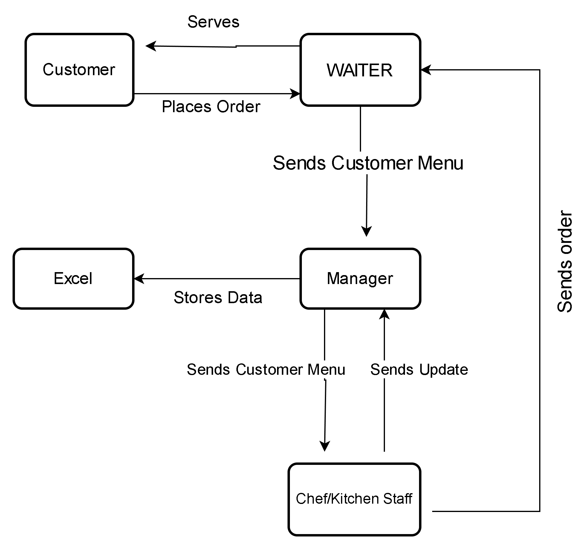

**Future Process Map**

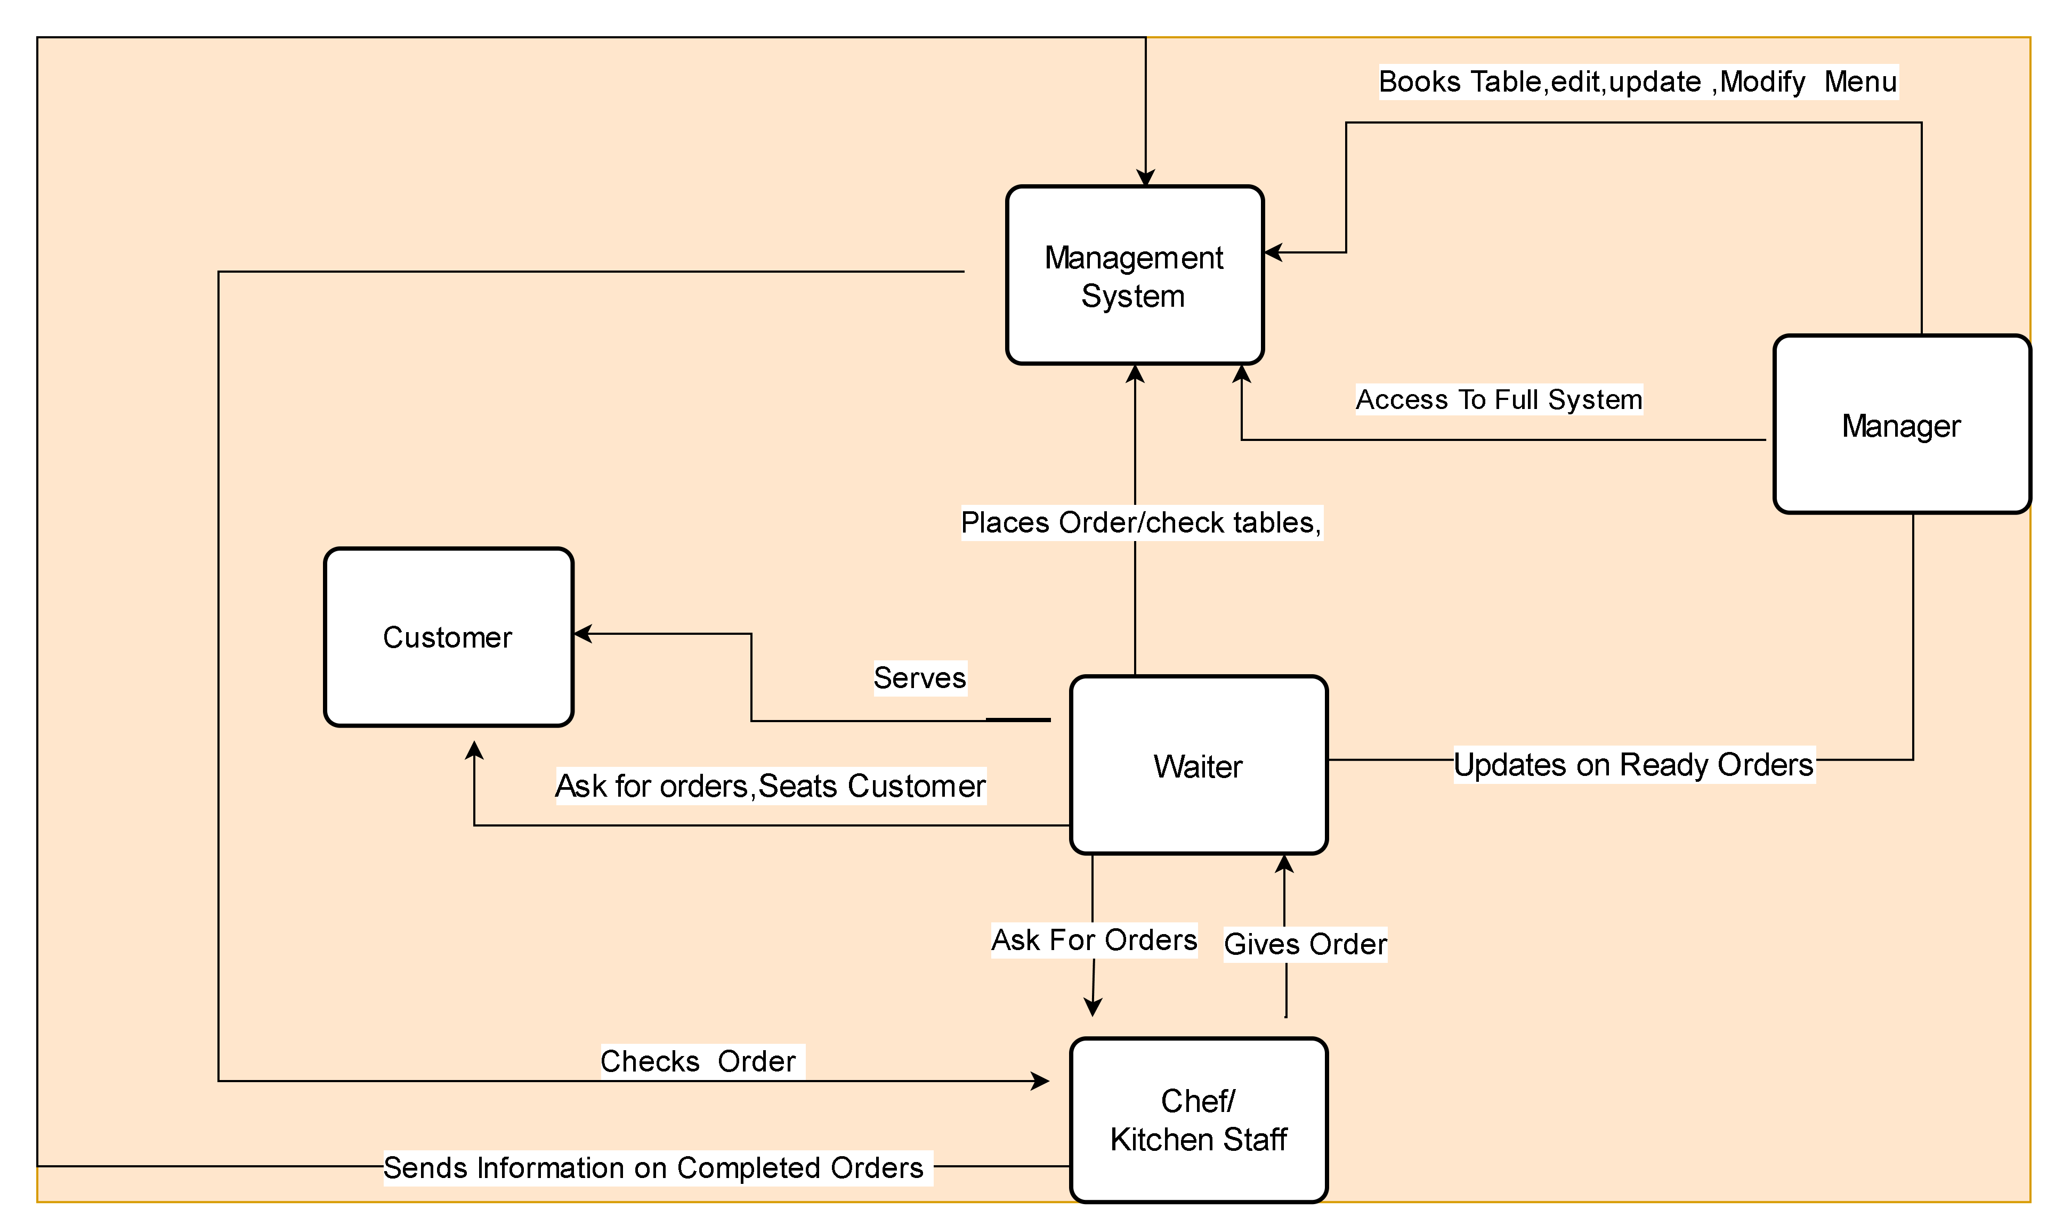

**The main features that need to be developed are**

1. **Menu Management:**
   * Creation, editing, and deletion of menu items.
   * Categorization of items into Starters, Soups, Main Course, Desserts, and Drinks.
   * Price association with each menu item.
   * Limited access to menu management for managers only.
2. **Search Facility:**
   * Waiters and managers should be able to search for items in the menu.
3. **Table Reservation System:**
   * Managers should be able to reserve tables.
   * Waiters should have access to view reserved tables and avoid seating customers on reserved tables.
4. **Bill Generation:**
   * Waiters use the system to generate bills for tables.
   * Bills should be tagged to the waiter, table number, and contain itemized details.
5. **Reporting Functionality:**
   * Total sales of the day by dine-in customers.
   * Total sales of the day by home delivery customers.
   * Consolidated total sales of the day (home delivery and dine-in customers).
   * Top 10 most sold dishes for the day.
   * Total sales every weekend (inputting dates).
   * Total sales every month (inputting dates).
   * List of dishes not sold in the current month.
   * Total sales across all cities.
   * Total sales for each city.
6. **User Authentication and Access Control:**
   * Login for waiters, managers, and the CEO (James Oliver).
   * Change password facility.
7. **Payment Gateway Integration:**
   * Customers can pay by cash or card through the system.
8. **Feedback Form:**
   * James Oliver desires a feedback form for customers.
   * Form captures details like name, address, mobile number, email, date of birth, and anniversary dates.
   * Managers manually input feedback form details into the system.
9. **System Administration:**
   * System administrators manage user access and system functionality.
   * Ensure the system's security and reliability.
10. **Responsive Design:**
    * User-friendly interface.
    * Responsive design to accommodate different devices, including mobile devices.
11. **Data Backup and Recovery:**
    * Mechanisms for data backup and recovery to prevent data loss.
12. **High Availability:**
    * Ensure the system is highly available during restaurant operating hours.
13. **Nonfunctional Requirements:**
    * Quick generation of reports.
    * Secure storage of menu and reservation data.
    * Maintaining the program in Java

**Scope of the Restaurant Management Software:**

* **In-Scope:**
  1. Menu creation and editing (limited to managers).
  2. Table Reservations (done by managers).
  3. Bill generation by waiters.
  4. Reporting functionalities.
  5. User authentication and access control.
  6. Payment gateway integration.
  7. Feedback form data entry.
* **Out-of-Scope:**
  1. Inventory management.
  2. Employee scheduling.
  3. Supplier management.
  4. Marketing and promotions.
  5. Customer relationship management beyond basic details.
  6. Integration with external systems not specified.

**Business Requirements**

**Functional Requirements:**

* Create, edit, and delete menu items (managers only).
* Search facility for waiters and managers.
* Table reservation system (managers only).
* Bill generation for dine-in customers.
* Differentiate sales by dine-in and home delivery.
* Top 10 most sold dishes report.
* Daily, weekend, and monthly sales reports.
* List of unsold dishes in the current month.
* Sales reports across all cities and for each city.
* User login and password change functionality.
* Payment gateway integration.
* Feedback form data entry by managers.

**Non-functional Requirements:**

* System should be user-friendly.
* Menu and reservation data should be securely stored.
* Reports should be generated quickly.
* High availability of the system during restaurant operating hours.
* Data backup and recovery mechanisms.
* Responsive design for mobile devices.
* Creating the program in Java.

**Wireframes for Table Reservation**

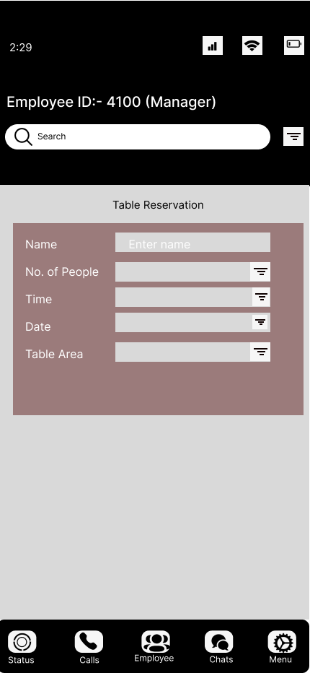

Wireframes for Menu Creation

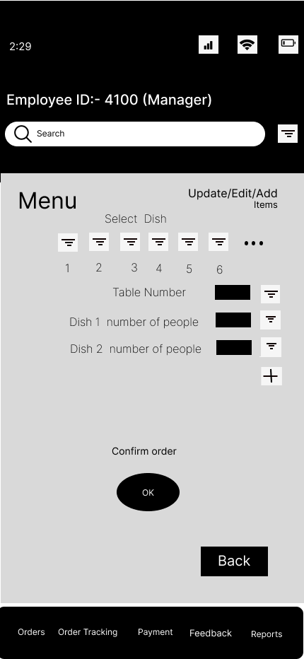

**Product Backlog of User Stories:**

1. **User Story: Menu Creation and Editing**
   * As a manager,
   * I want to create, edit, and delete menu items,
   * So that I can keep the menu updated with the latest dishes.
   * **Acceptance Criteria:**
     + Managers should be able to add a new menu item with a name, price, and category.
     + Managers should be able to edit the details of an existing menu item.
     + Managers should be able to delete a menu item.
2. **User Story: Menu Categorization**
   * As a manager,
   * I want to categorize menu items into Starters, Soups, Main Course, Desserts, and Drinks,
   * So that customers can easily find their desired items.
   * **Acceptance Criteria:**
     + Each menu item should belong to one of the specified categories.
3. **User Story: Table Reservation**
   * As a manager,
   * I want to reserve tables,
   * So that we can provide a better dining experience by managing table availability.
   * **Acceptance Criteria:**
     + Managers should be able to mark a table as reserved.
     + Waiters should see the reservation status of a table and avoid seating customers on reserved tables.
4. **User Story: Bill Generation**
   * As a waiter,
   * I want to generate bills for tables,
   * So that customers can make payments for their orders.
   * **Acceptance Criteria:**
     + The bill should include itemized details of the order.
     + The bill should be tagged with the waiter's name and the table number.
5. **User Story: Sales Reports**
   * As a manager,
   * I want to generate sales reports for different periods and categories,
   * So that I can analyze trends and make informed decisions.
   * **Acceptance Criteria:**
     + Total sales for dine-in customers should be calculated for the day.
     + Total sales for home delivery customers should be calculated for the day.
     + Consolidated total sales for the day (including dine-in and home delivery) should be calculated.
     + Top 10 most sold dishes for the day should be identified.
     + Total sales should be calculated for weekends and months (inputting dates).
6. **User Story: User Authentication and Access Control**
   * As a system user (waiter, manager, or CEO),
   * I want to log in and change my password,
   * So that we can secure access to the system.
   * **Acceptance Criteria:**
     + Users should be able to log in with valid credentials.
     + Users should be able to change their password.
7. **User Story: Payment Gateway Integration**
   * As a customer,
   * I want to pay by cash or card through the system,
   * So that I have multiple payment options.
   * **Acceptance Criteria:**
     + The system should have a payment gateway for card transactions.
     + Waiters should be able to record cash payments.
8. **User Story: Feedback Form Integration**
   * As a manager,
   * I want to manually input feedback form details into the system,
   * So that we can collect and analyze customer feedback.
   * **Acceptance Criteria:**
     + The system should allow manual entry of customer feedback form details.
     + Details like name, address, mobile number, email, date of birth, and anniversary dates should be captured.

**Tableau Questions**

**To view sales of restaurants for the last six months.**

**To show which zone (Zone 1, 2, 3, or 4) has highest sales.**

<https://public.tableau.com/views/Book2_17029761537820/Dashboard1?:language=en-US&publish=yes&:display_count=n&:origin=viz_share_link>

**Excel Task :**

* Create a bar graph for San Jose, Madison, and New York showing the sales. Label the chart drawn correctly so that senior management gets a clear report of sales.
* Arrange the data above in excel in an ascending and descending order for each city.
* restaurant ID 1200789, find the sales for the month of June
* restaurant ID 1200739, find the sales for the month of April
* restaurant ID 1200352, find the sales for the month of January

